Mount Rushmore

History
The Mount Rushmore project began in December of 1923 when the state historian of South Dakota suggested a sculpture in the Black Hills. In order to create the sculpture 820,000,000 pounds of rock were blasted off the mountainside, the details were carved with drills, and these smaller pieces were removed by hand. On October 31, 1941, Mount Rushmore National Memorial (https://www.nps.gov/moru/index.htm) was declared a completed project.
Central Figures
The efforts of six men in particular were critical to the vision and the execution of this national memorial. The following table lists them by name, occupation, and role:
Name | Occupation & Contributions
Doane Robinson | State Historian of South Dakota | - Conceived of the original idea  - Invited Borglum to visit and talk over the project  - Worked to secure funding to start the project
John Boland | Mayor of Rapid City; President and General Manager of the project | - Worked with Robinson to secure the initial funding  - Maintained adequate funding for the project––even through the Great Depression
Gutzon Borglum | Sculptor | - Oversaw all sculpting operations for the project  - Conducted world tours to raise funds
Lincoln Borglum | Pointer; Chief Pointer; Sculptor | - Worked for several years without pay in different positions  - Took over the role of sculptor after his father's death

The Workers
Almost 400 men and women labored for fourteen years to create Mount Rushmore. The laborers worked long hours for low pay, with little certainty as to how long he would be employed.
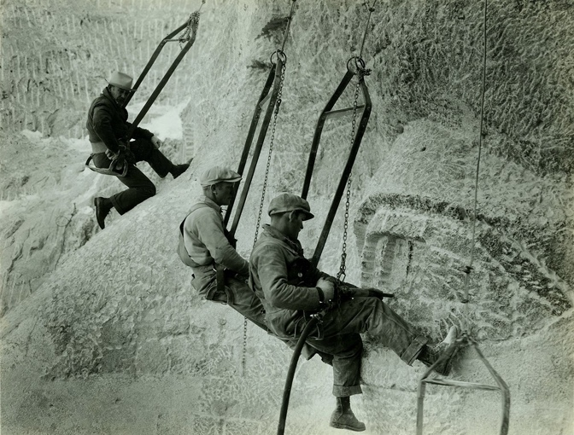
Despite dangerous and harsh conditions, there were no fatalities during the carving work.

The Presidents

There are four U.S. presidents featured in the memorial. Borglum chose these four presidents because they represented the most important events in the history of the United States. From left to right the presidents are Washington, Jefferson, Roosevelt, and Lincoln. Below are pictures of each president with a link to a Wikipedia page about him.

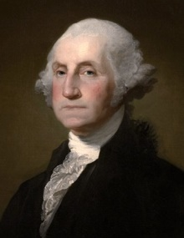
George Washington
George Washington led the colonists to victory in the American Revolutionary War. He was the first president of the new country and is often referred to by Americans as "The Father of our country". Washington’s face were completed in 1934.

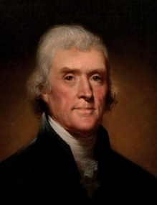
Thomas Jefferson
Thomas Jeferson was the primary author of the Declaration of Independence. He also purchased the Louisiana Territory while serving as the third president of the United States, which doubled the size of the country. Jefferson’s face was completed in 1936.

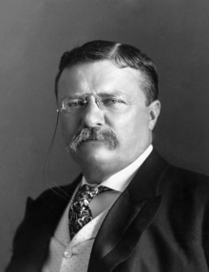
Theodore Roosevelt
As the 26th president, Theodore Roosevelt was instrumental in negotiating the construction of the Panama Canal. He also worked to end large corporate monopolies and ensure the rights of the common working man. Roosevelt’s face was completed in 1939.

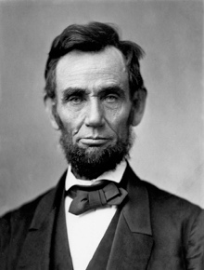
Abraham Lincoln
Abraham Lincoln was the 16th president of the United States during the country's greatest trial––the Civil War. He believed his most sacred duty was to "preserve the Union", and he worked tirelessly to abolish slavery. Lincoln’s face was completed in 1937.

Today's Visitors
The park is open seven days a week––all year––except for December 25. Over two million people visit the park each year.

Park Attendance

Year | Visitors
2010 | 2,331,237
2011 | 2,081,722
2012 | 2,185,447
2013 | 2,162,998
2014 | 2,144,808
2015 | 2,434,297
2016 | 2,431,231
Over the years, new visitor facilities have been added, including a visitor center, the Lincoln Borglum Museum, and the Presidential Trail.

